Welcome back folks. If you missed the previous edition of this article please go and check it out in the MagPi issue #2. Above is a quick reference sheet for the Schism Tracker function keys that you can keep referring back to whilst you read this article. It can be helpful to print this out and put it on your wall.

## What we're going to do

By the end of this we should have programmed the melody for Dj Quicksilver's Bellissima. This is a really famous dance tune that came out in 1997. You've probably heard it before, but you just don't know it by name You can Google it if you want to. The tune has quite a simplistic melody but a catchy one and it is ideal for getting to grips with Schism Tracker.

### Setting up

I'm going to assume we're using Raspbian for this. Firstly we need to install the Schism Tracker program. You can either use the Pi Store to install it, you will find it under Apps, or you can use the command sudo apt-get install schism. If you install it via the Pi Store you can launch the program via the Pi Store > My Library area or, if you used apt-get, you can find Schism Tracker listed in the X desktop launcher menu under Other.

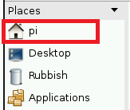Firstly we need to create some folders to store our stuff. We need one folder to save songs files into and another for sound effect files (instrument sounds). Start the X desktop if you haven't already (startx). Open the File Manager program and click on pi under places.

From the top menu select; File > Create New > Folder. Name the folder schism.

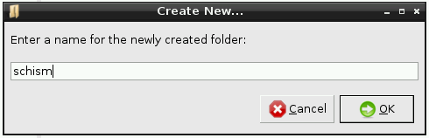

Open this folder and inside it create two more folders, one called songs and another called samples.

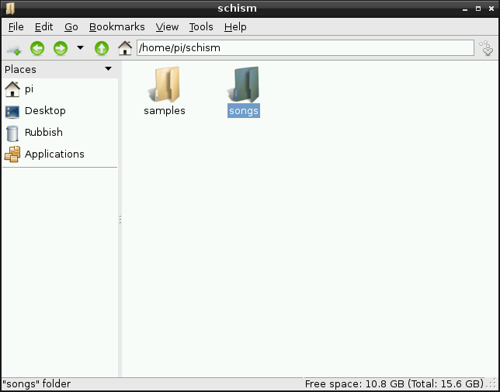

Run Schism Tracker and press the F12 key. At the bottom part of the screen you should see an area labelled 'Directories'. There should be three rows, Module, Sample and Instrument. Don't worry about Instrument for now. But change module so it says /home/pi/schism/songs and change Sample so that it says /home/pi/schism/samples. Once you're done click *Save all Preferences*.

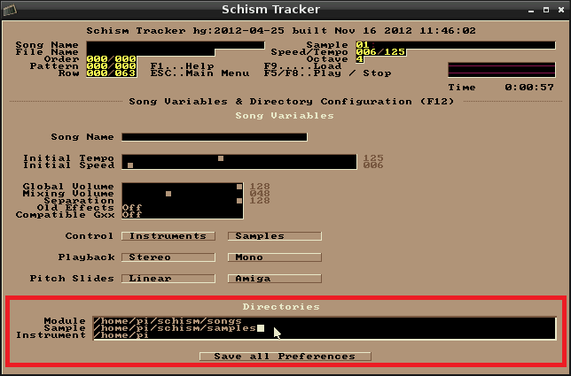04.png

### Downloading a sample

We have a pre-prepared sample ready to use for the main melody. You can either use Midori or wget from a command prompt to download it: https://dl.dropbox.com/u/14125489/RaspberryPi/Schism/bellissima.raw

Save this file into the samples folder that we created before (or save it anywhere and then move it to the samples folder).

### Loading the sample

Go back to Schism Tracker now, don't load any songs - just leave it blank. Press the F3 key. This is the sample list page. Don't worry about all the stuff on the right hand side. Look at the list on the left, this will be where each sound effect or vocal will be loaded in your song. One can be loaded for each row. Select any row you like and press the Enter key.

You should now see a row showing belissima.raw, select it and press Enter again. You should now be back on the sample list page. Keep the belissima sample selected (put the cursor over Play) and run your finger up and down between Q and P on your keyboard. You'll see this is like the notes of a piano. Some of the number keys on the row above represent the black keys too.

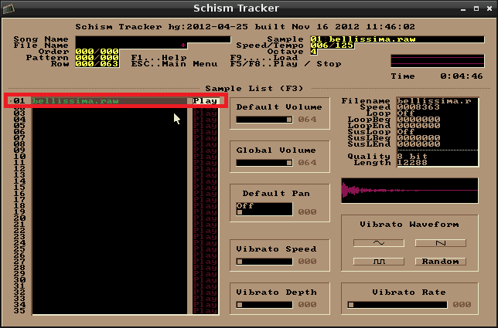05.png

### Try this

Stay on the sample list but press these keys with the belissima sample selected (keep the cursor over Play).

6 6 6 e e e y y 5 5 5 u u y 9 y

You should be able to make out the melody of the tune! Now we have to program it into a sheet of music knows as a *pattern* so that the melody is stored somewhere.

### Programming the melody

Press the F2 key to go to the pattern editor screen. You are now looking at a pattern number 000 (think of it like a sheet of music). You'll see across the top Channel 01, Channel 02 etc and down the left hand side numbers running from 000 to063 (so 64 rows in total).

The way this works is that we select a sample from the sample list (F3) go to the pattern editor screen (F2) and program notes into the available rows of a channel. Ideally you should always use a separate channel for each sample but you don't have to. When the computer plays the pattern it moves down the screen playing all the notes that occur on each row (across all Channels). So the effect is that sounds from each channel are played together at the same time (mixed together) to form the overall sound of the song.

So let's put our melody into Channel 01. The cursor (a little white square) should already be inside the channel, you can move it around using the cursor keys or by the mouse. Start at row 000 and on every other row type in a note from the melody sequence 6 6 6 e e e y y 5 5 5 u u y 9 y. You should finish up on row 030 (see below). Now press the F6 key to play back the pattern, watch how the white highlight of the row numbers moves down the left side. Tap your foot to the tune. Press F8 to stop.

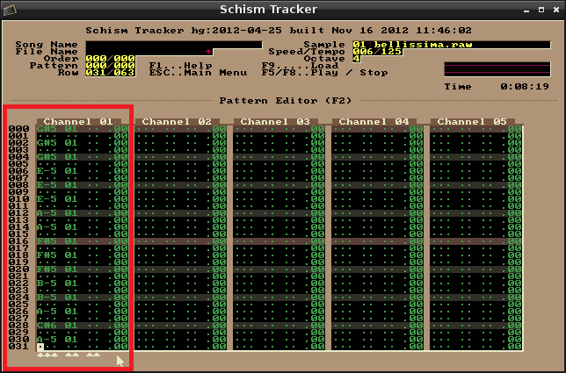06.png

You will notice that there is a gap of silence before the melody starts up again, this is because we have not put any notes below row 030 of the pattern. If you now go to row 032 and repeat the same sequence of notes finishing on row 062 the melody will now loop continuously when you press F6. F8 again to stop.

Congratulations you have just programmed your first pattern! Now we need to make this pattern part of the actual song. You'll notice that if you now press F5 to play the song, like we were doing in the previous article, nothing happens. This is because the pattern order list has not been set yet. Press the F11 key for this.

Note: In the Raspberry Pi desktop (LXDE) there is a bit of key binding silliness going on. You may find that pressing F11 causes Schism Tracker to go into full screen mode and not to the pattern order list like it should. This is because F11 is a maximise toggle shortcut key in LXDE. You should avoid using Schism Tracker in full screen mode because it will run slowly. You can work around this by pressing Ctrl + D. This will make Schism Tracker grab the keyboard and mouse input. Then F11 should work correctly. Press Ctrl + D again to release. Remember that while Schism Tracker has grabbed the input the mouse cursor will not be able to move outside of the Schism Tracker window.

Once you're on the pattern order list screen don't worry about the middle and right hand columns. The left hand column is where the pattern order is kept.

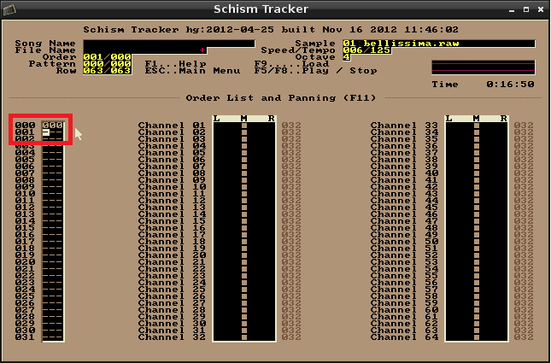07.png

Go to the first row and enter 000 as shown above (this is the number of the pattern you have just programmed). Now if you press F5 you'll hear the music (just like when you play a normal song file). Press F8 to stop the playback and go back to the pattern order list again (F11). On the second row enter 001. Now press F5 again. You'll hear the melody play and then it'll go silent for a bit. This is because we have not programmed anything into pattern 001 yet.

### Copy and Paste

Press F2 again to go back to the pattern editor. You can use the + and - keys to switch between patterns. Notice the pattern number change at the top of the screen where it says Song Name, File Name, Order, *Pattern* and Row.

08.png

Before you start worrying that you have to type in all the notes again; there is a copy and paste function. This is ideal if you want the next pattern in the song to be the same but with one extra sound for instance.

Go back to pattern 000 and put the cursor at the top of Channel 01. Hold down the Shift key and use the cursor/arrow keys to select the entire column (from rows 000 to 063). Press Alt – C to copy the notes into memory. Now press the + key to go to pattern 001. Place the cursor at the top of Channel 001 and press Alt – P to paste.

What we need now is another sample to make it sound like something is happening in the song.

Go and use Midori or wget to download this sample; https://dl.dropbox.com/u/14125489/RaspberryPi/Schism/kickdrum.raw

Save it into the samples folder like before. This is a fairly meaty sounding kick drum which will work quite well with the melody we already have. In Schism Tracker Press F3 to go to the sample list again, select a blank row and press Enter. Select the kickdrum.raw file and press enter again. You can now test it out with the Q to P keys if you want. The I key sounds best I think.

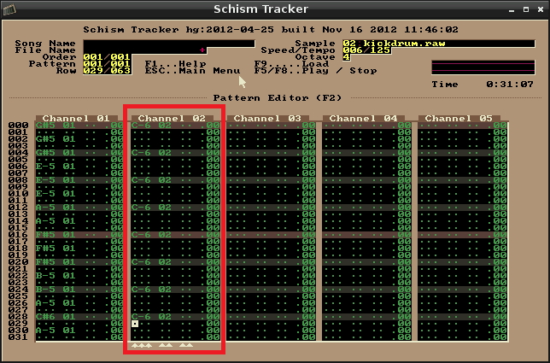09.png

With the kick drum sample selected switch back to the pattern editor, F2, and put the cursor at the top of Channel 02. Use the I key to place kick drum beats every 4 rows, make them follow the highlighted lines as shown above. Go all the way down to line 60.

If you now press F5 to play the entire song, you'll hear the melody loop play twice before the kick drum comes in. Cool hey?

### Saving to disk

Okay lets save the song to disk now, press the F10 key, enter a file name as shown below and press enter.

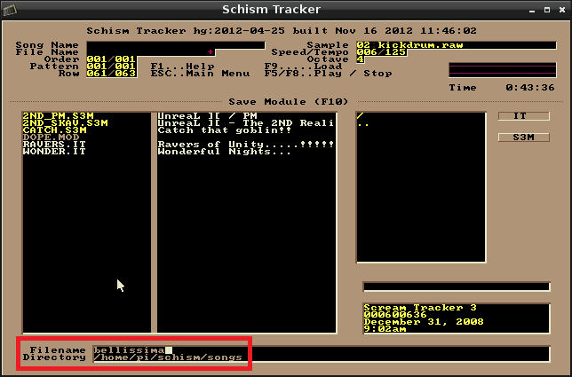10.png

Congratulations you have just made your first module! It might be time to turn the volume up, marvel at what you have just done and annoy your parents a bit!

Just as a test you can quit out of Schism Tracker (Ctrl - Q), run the program again and check that you can load your song and play it. Press F9 for the Load Module screen, you should see your song is now shown in the list (see below). Select it, press enter and then press F5 to play it.

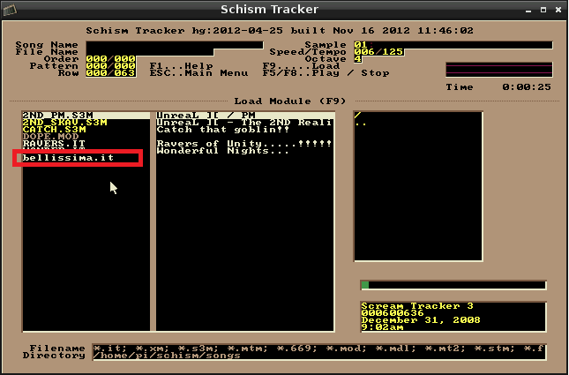11.png

The song file extension is .IT which stands for Impulse Tracker, the original MS-DOS program that Schism Tracker is an open source version of. The .IT song files contain all the samples and pattern information can be emailed whole to a friend. The recipient just needs a copy of Schism Tracker or any software that can play IT files. Note that Schism Tracker is available on most platforms, including Microsoft Windows and Apple OSX. So I encourage you to share your songs with your friends, there is a lot of fun to be had in doing this.

### Ripping samples

So with what you have learnt here you are probably in a good position to start experimenting, but I expect you're wondering where to get more samples and sound effects from! There are numerous solutions to this; you could search the internet for ‘free sample packs’, which can be a little hit and miss, *or* you can steal the samples that you like from other module files! This is incredibly effective because you can hear how people are using samples in their own songs first. Great for vocals!

If you haven't done so already head over to http://modarchive.org/ and go Music > Charts > Top Favourites. Download a few of them and start checking them out for samples that you like. F9 to load a song, F5/F8 for play/stop and then F3 to see the sample list.

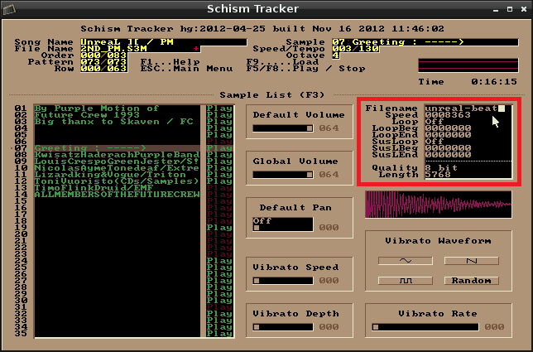12.png

Use the cursor keys to move up or down the list and test each sample out with the Q to P keys. When you find one that you like you can press ALT-W to save it to disk (this will save a file to the samples folder that we created earlier). If you see an error it'll be because the sample has no filename on the right hand side. Just make sure you have typed a filename here (see above) and try ALT-W again.

Press F9 to load your belissima module up again (ignore the warning to save the current module). Press F3, select an empty row and press enter. The sample that you exported should now show in the list (see below). Select it, press enter, the sample is now loaded into your module and can be used to program a pattern in exactly the same way as demonstrated earlier.

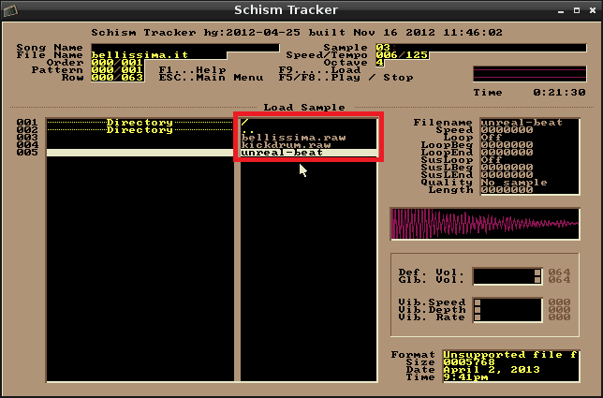13.png

Obviously we're still only scratching the surface of what Schism Tracker can do here, expect more Schism Tracker articles in the future though!

Here is something for you to try on your own. Copy and paste pattern 001 (melody and kick drum) into 002, after doing that copy everything in Channel 01 to Channel 03. You will notice that the overall effect of duplicating a sample over two channels is that the sound becomes louder. See if you can integrate this into the song somehow. Remember that you have to enter new patterns into the list on the F11 screen. Press F1 for the Help. Good luck and have fun!